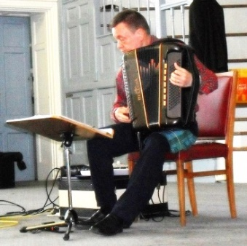

DANCE SCOTTISH

HEREFORDSHIRE BRANCH ANNUAL DANCE
SATURDAY, 4th May 2024

SAXON HALL, HOARWITHY ROAD, HEREFORD, HR2 6HE
7.00 pm to 10.30 pm
Dancing to IAN SLATER

P R O G R A M M E

Dances will be recapped

Currie Mountain | R 8x32 | Mr Iain Stuart Robertson | R 8x32
Machine Without Horses | J 8x32 | Elephant’s Stampede | J 4x48 Sq set
Blue Mess Jacket | S 4x32 | Neidpath Castle | S 3x32
The Raven’s Dance | J 8x32 | Farewell to Balfour Road | J 96
Never at Sea | R6x48 | Swiss Lassie | R 8x32
Sands of Morar | S 8x32 | Orchards of County Armagh | S 3x32
Major Ian Stewart | J 8x32 | Ian Powrie’s Farewell to Auchterarder | J 128 Sq set
Black Mountain Reel | R 5x32 | Montgomeries’ Rant | R 8x32
Sandy’s Scotch Broth | S 3x32
Gothenburg’s Welcome | J 8x32

EXTRAS: Linton Ploughman J 8x32 Reel of the 51st Division R 8x32 Autumn in Appin S 4x32

AMERICAN SUPPER. COFFEE, SQUASH PROVIDED

CRIB/TICKET: £10.00 (no fee for spectators)

Crib/Tickets can be obtained from Herefordshire Club Secretaries
or
Jane McIntosh – jane.mcin@googlemail.com
June Rynn – juneorynn@gmail.com

If you wish to pay by BACS transfer, please use the following details:
Account name: “Herefordshire Bran”. Account number 50430579 Sort Code 40-24-11
Ref: surname and initial(s) followed by May24

If paying by cheque, please make payable to: RSCDS Herefordshire Branch

